2018-2019
Northeast Elementary
School Schedules

Regular Schedule
- Doors Open 7:50
- Breakfast: 7:50-8:10
- Instruction Begins: 8:10
- School Ends: 3:10

Dismissal Times
Regular :
- Car Riders/Day Care: 2:55
- Bus Riders: 3:00
Half Day:
- Car Riders/Day Care: 11:25
- Bus Riders: 11:30
Early Release:
- Car Riders/Day Care: 12:35
- Bus Riders: 12:40

Pre-K Schedule
- 9:30-3:00
Do Not Report:
- Half Days
- Early Release
- 2 hr. Delay

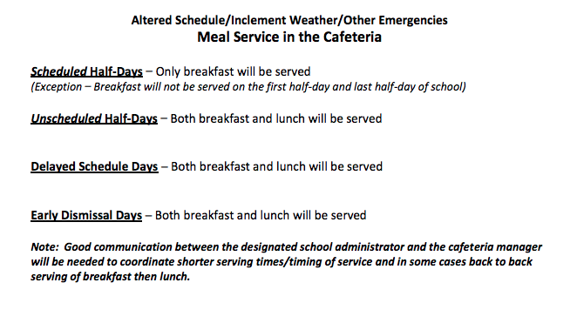
Inclement Weather/ Other Emergencies
When Schools Release Early
The CMCSS communication office will send out information thru email, school messenger
Automated calls, television/radio notification
Please make sure your child’s School Emergency Card contains the most up-to-date contact information for parents and guardians as this information will be used by the CMCSS Communications Office for automated School Messenger phone and email messages.
As we enter the months where snow and icy weather is possible, school can be a very hectic place, buses are arriving and we are dismissing quickly. It is important that your child knows and understands your instructions on how they will leave school. Also, it is important that your child’s teacher knows how they will go home. If you have not given your child’s teacher that information, please do so as soon as possible!

AFTERNOON CHANGES IN TRANSPORTATION CANNOT BE MADE BY PHONE.
This is a CMCSS district policy.

